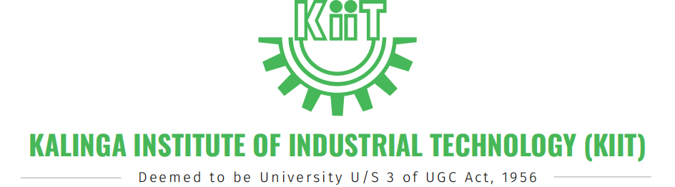


Power Bi Project On
Amazonia Retail Analytics

Name: Rauneet Agrawal
Roll Number: 2305232
Program: B.Tech CSE
Academic Year: 2023–2027
Tool Used: Microsoft Power BI Desktop
SUBJECT CODE:IS30074
SEMESTER: 6TH
YEAR: 2025-2026



Problem Statement & Objective

Problem Statement
In an e-commerce business, all customers are often treated equally, which leads to inefficient marketing strategies and reduced profitability. Businesses lack insights into customer behavior, making it difficult to identify high-value customers and retain them effectively.
This project analyzes customer data to identify patterns based on demographics, purchasing behavior, and frequency to improve decision-making.

Objective
Design and develop an interactive Power BI dashboard that:
- Tracks key KPIs such as total customers, revenue, and average spending
- Segments customers into High, Medium, and Low categories
- Provides insights into customer purchasing behavior
- Enables filtering for deeper analysis
- Supports data-driven business decisions

Page 3: Dataset & Methodology

Dataset
File: customer_segmentation_dataset.csv
Attribute | Details
Total Records | 100 customers
Features | 7 columns

Columns
Column | Description
CustomerID | Unique customer identifier
Age | Customer age
Gender | Male / Female
City | Customer location
Purchase Amount | Total spending
Purchase Frequency | Number of purchases
LastPurchaseDate | Last purchase date

Methodology
The project follows a structured approach:
- Data Collection – Importing dataset into Power BI
- Data Cleaning – Handling missing values using Power Query
- Data Transformation – Formatting and preparing data
- DAX Calculations – Creating measures (Revenue, Avg Spending)
- Visualization – Creating charts and KPIs
- Dashboard Design – Building an interactive dashboard

Page 4: Dashboard & Insights

Dashboard Preview

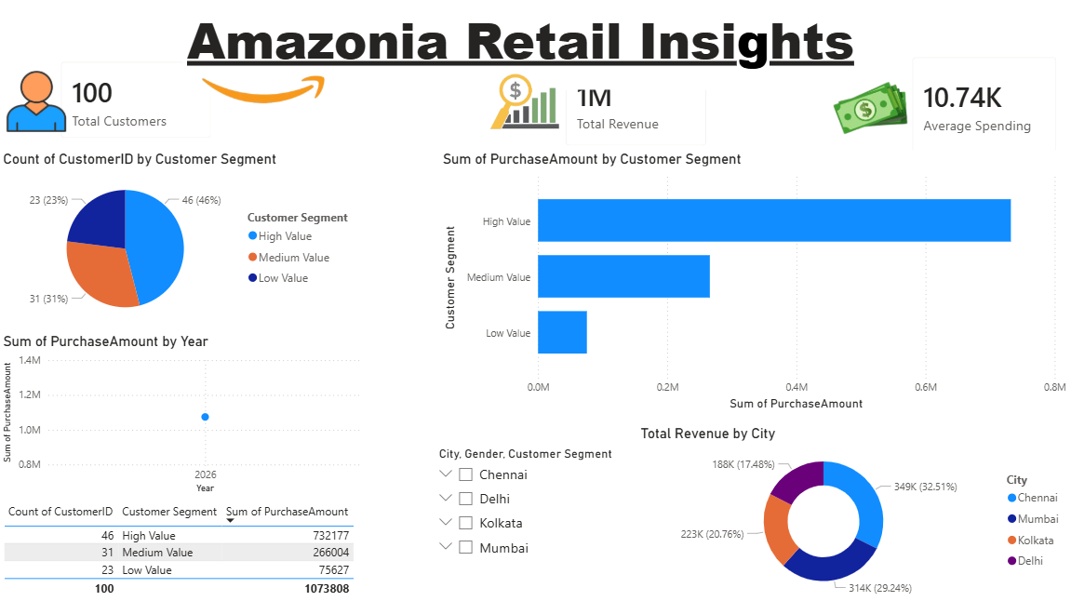

Key Features

KPI Cards
- Total Customers
- Total Revenue
- Average Spending

Visuals Included
Visual | Insight
Customer Segmentation (Pie) | Distribution of High, Medium, Low customers
Revenue by Segment (Bar) | Identifies highest revenue group
Sales Trend (Line) | Tracks purchasing over time
City-wise Analysis | Shows performance by location
Customer Table | Detailed customer data

Insights
- High-value customers contribute the majority of revenue
- Medium segment contains the largest number of customers
- Certain cities show higher purchasing behavior
- Frequent buyers generate consistent income

Tech Stack, Future Scope & Conclusion

Tech Stack :-
Component | Technology
BI & Visualization | Microsoft Power BI Desktop
Data Source | CSV File
Data Transformation | Power Query
Calculations | DAX
Filters | Power BI Slicers

Unique Aspects
- Dual segmentation based on spending and frequency
- Interactive and user-friendly dashboard
- Business-focused insights
- Clean and professional UI

Future Improvements
- Machine learning for customer prediction
- Real-time data integration
- Customer churn analysis
- Customer lifetime value (CLV) analysis
- Mobile-optimized dashboard

Conclusion
Customer segmentation is a powerful technique that helps businesses understand their customers better. This project demonstrates how data visualization using Power BI can improve business strategies and decision-making.

License
This project is developed for academic purposes as part of the B.Tech CSE curriculum.
All data used is synthetic and intended for educational analysis only.



